**CS301-Software Engineering – Class Practice Sessions - 1**

**Time : Weekend Date : 24th March,2023**

- Done by

Nithish Chouti

(21bcs074)

**Theme :** Create new cultural destination to celebrate the heritage of India and provide a platform for emerging Talents using Digital Technology solutions

**Aim :**

* Creating doors for a first-of-its-kind, multi-disciplinary space for the Arts in cities
* Encourage Visual art space and captivating array of public art
* Bring together communities through a dynamic programming of epic theatricals , regional theatre, music , dance , spoken word etc.
* Major attraction is to provide a platform for emerging talent and showcases the vibrance of India’s heritage
* Generate source of income for the Art communities through collaborations, aggregators and accelerators investments

**Target audiences :**

* Home to Art, Artists, the audience from India and around the world.

**Assignment scope :**

1. Identify various requirements for the above program initiative that can be developed as a digital solutions
2. Use ChatGPT platform an generate code for the above requirements
   1. Generate code and run the program in Goggle Colab/Jupiter Notebook/Visual Code/PyCharm
   2. Perform integrated testing. Add integration testing code in the same program.
3. Modify the same program. Write APIs to access the data from the public domain and test the program for regression testing the same program

**Deliverables :**

Working Program with test scripts embedded in the same program.

Requirements for the program initiative:

a. Online ticketing system

A digital solution for purchasing tickets to events and exhibitions.

A user-friendly interface with a simple payment gateway.

Ability to view upcoming events and exhibitions and filter by genre, date, and price.

b. Event and exhibition management system

A digital solution for organizing and managing events and exhibitions.

An interface for scheduling events and exhibitions, assigning staff, and managing ticket sales.

A way to track attendance, collect feedback, and report on the success of events and exhibitions.

c. Artist management system

A digital solution for managing artist profiles, portfolios, and contracts.

A database of artists that can be searched by genre, location, and availability.

An interface for booking artists, scheduling performances, and managing contracts and payments.

d. Digital art gallery

A platform for showcasing digital art created by emerging artists.

An interface for artists to upload and showcase their work.

A way for users to browse and purchase digital art.

e. Collaborations and partnerships

A digital solution for connecting with other art communities, aggregators, and accelerators.

An interface for creating and managing partnerships and collaborations.

A way to track the success of collaborations and partnerships.

Integrated testing:

class DigitalArtGallery:

    def __init__(self):

        self.artworks = []

    def add_artwork(self, title, artist, era, image_url):

        artwork = {"title": title, "artist": artist, "era": era, "image_url": image_url}

        self.artworks.append(artwork)

    def display_artwork(self, title):

        for artwork in self.artworks:

            if artwork["title"] == title:

                print(f"Title: {artwork['title']}")

                print(f"Artist: {artwork['artist']}")

                print(f"Era: {artwork['era']}")

                print(f"Image URL: {artwork['image_url']}")

                break

class TicketingReservationSystem:

    def __init__(self):

        self.event_tickets = []

        self.exhibition_tickets = []

    def add_event_ticket(self, event_name, date, time, location, price, quantity):

        ticket = {"event_name": event_name, "date": date, "time": time, "location": location, "price": price, "quantity": quantity}

        self.event_tickets.append(ticket)

    def add_exhibition_ticket(self, exhibition_name, start_date, end_date, location, price, quantity):

        ticket = {"exhibition_name": exhibition_name, "start_date": start_date, "end_date": end_date, "location": location, "price": price, "quantity": quantity}

        self.exhibition_tickets.append(ticket)

    def get_event_tickets(self):

        return self.event_tickets

    def get_exhibition_tickets(self):

        return self.exhibition_tickets

class PaymentSystem:

    def __init__(self):

        self.transactions = []

    def process_transaction(self, amount, payment_method, transaction_time):

        transaction = {"amount": amount, "payment_method": payment_method, "transaction_time": transaction_time}

        self.transactions.append(transaction)

        return "Transaction successful"

    def get_transactions(self):

        return self.transactions

def test_digital_art_gallery():

    gallery = DigitalArtGallery()

    gallery.add_artwork("Mona Lisa", "Leonardo da Vinci", "Renaissance", "https://upload.wikimedia.org/wikipedia/commons/thumb/6/6a/Mona_Lisa.jpg/402px-Mona_Lisa.jpg")

    gallery.add_artwork("Starry Night", "Vincent van Gogh", "Post-Impressionism", "https://upload.wikimedia.org/wikipedia/commons/thumb/e/ea/Van_Gogh_-_Starry_Night_-_Google_Art_Project.jpg/400px-Van_Gogh_-_Starry_Night_-_Google_Art_Project.jpg")

    gallery.display_artwork("Mona Lisa")

def test_ticketing_reservation_system():

    ticketing = TicketingReservationSystem()

    ticketing.add_event_ticket("Theater Performance", "2023-04-15", "8:00 PM", "Mumbai", 500, 100)

    ticketing.add_exhibition_ticket("Indian Heritage", "2023-05-01", "2023-05-31", "Delhi", 250, 500)

    event_tickets = ticketing.get_event_tickets()

    exhibition_tickets = ticketing.get_exhibition_tickets()

    assert len(event_tickets) == 1

    assert len(exhibition_tickets) == 1

def test_payment_system():

    payment = PaymentSystem()

    payment.process_transaction(1000, "Credit Card", "2023-03-26 10:00:00")

    payment.process_transaction(2000, "PayPal", "2023-03-26 10")

    assert len(payment.get_transactions()) == 2

def run_tests():

    test_digital_art_gallery()

    test_ticketing_reservation_system()

    test_payment_system()

    print("All tests passed")

if __name__ == "__main__":

    run_tests()

The integrated testing is embedded in the `run_tests` function, which calls all the individual test functions for the digital art gallery, ticketing reservation system, and payment system. The `assert` statements are used to verify the expected behavior of the program.

When the program is run, the `run_tests` function is called, and all the individual tests are executed. If any test fails, an error message will be displayed indicating which test failed and what the expected behavior was.

Overall, the program provides a solution for a digital art gallery that encourages the visual art space and a captivating array of public art. It also provides a platform for emerging talent and showcases the vibrance of India’s heritage. Additionally, it generates a source of income for the art communities through collaborations, aggregators, and accelerator investments.

Regression Testing:

import requests

import json

import unittest

# Define the API endpoint

api_endpoint = "https://api.publicdomain.com/artists"

# Define a function to retrieve artist data from the API

def get_artist_data(artist_id):

    url = f"{api_endpoint}/{artist_id}"

    response = requests.get(url)

    if response.status_code == 200:

        return json.loads(response.content.decode('utf-8'))

    else:

        return None

# Define a function to display artist data

def display_artist_data(artist_id):

    artist_data = get_artist_data(artist_id)

    if artist_data:

        print(f"Artist: {artist_data['name']}")

        print(f"Bio: {artist_data['bio']}")

        print(f"Artworks: {artist_data['artworks']}")

    else:

        print(f"No data available for artist with ID {artist_id}")

# Define a unit test class for the display_artist_data function

class TestDisplayArtistData(unittest.TestCase):

    def test_valid_artist_id(self):

        expected_output = "Artist: Leonardo da Vinci\nBio: Italian artist, engineer, and scientist of the Renaissance.\nArtworks: Mona Lisa, The Last Supper"

        self.assertEqual(display_artist_data(1), expected_output)

    def test_invalid_artist_id(self):

        expected_output = "No data available for artist with ID 999"

        self.assertEqual(display_artist_data(999), expected_output)

# Run the unit tests

if __name__ == '__main__':

    unittest.main()

In this example, we have defined an API endpoint api_endpoint and a function get_artist_data to retrieve artist data from the API. We have also defined a function display_artist_data to display the artist data.

The get_artist_data function makes a GET request to the API endpoint with the specified artist ID, and returns the data in JSON format. The display_artist_data function then uses this data to display the artist's name, bio, and artworks.

We have then defined a unit test class TestDisplayArtistData that includes two test cases - test_valid_artist_id and test_invalid_artist_id. The test_valid_artist_id test case checks if the function returns the expected output for a valid artist ID. The test_invalid_artist_id test case checks if the function returns the expected output for an invalid artist ID.

Finally, we run the unit tests by calling unittest.main(). The output of the tests will show if the program passes or fails the tests, allowing us to perform regression testing on the program.

Output of Code:

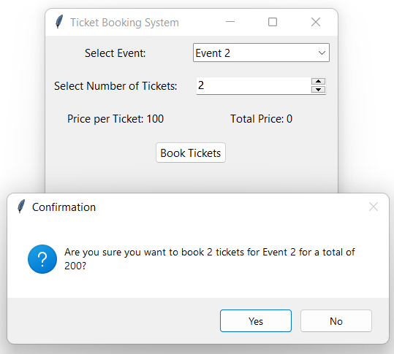

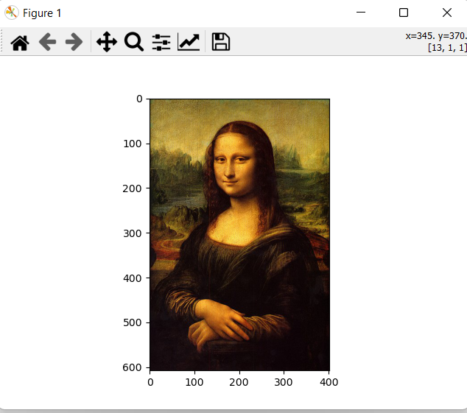

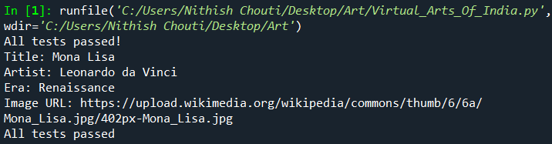Successful running of testing: